**JESSY: INTELLIGENT TRAVEL ASSISTANCE**

Project ID: 2021-014

Project Status Document 1 - Individual

**Herath H.M.C.J – IT18116748**

B.S c. ( Hons) Degree in Information Technology

Department of Information Technology

Sri Lanka Institute of Information Technology

Sri Lanka

June 2021

**Table of Content**

1) Microsoft Teams Chat and Meetings 3

2) Microsoft Team Project Plan 7

3) Microsoft Planner Overall Analysis of Tasks 8

4) Work Breakdown Structure 10

5) Gantt Chart 11

**Table of Content**

Figure 1 – Meeting 18 Jan 2021 3

Figure 2 – Meeting 15 Feb 2021 3

Figure 3 – Meeting 20 Feb 2021 4

Figure 4 – Meeting 11 Mar 2021 4

Figure 5 – Frontend Discussion Meeting 17 Apr 2021 5

Figure 6 – Meeting 27 May 2021 5

Figure 7 – Meeting 30 June 2021 6

Figure 8 - Project Plan 7

Figure 9 -My Tasks Chart - 1 8

Figure 10 - My Tasks Chart - 2 8

Figure 11 - My Task Chart - 3 9

Figure 12 - Work Breakdown Chart 10

Figure 13 - Gantt Chart 11

# Microsoft Teams Chat and Meetings

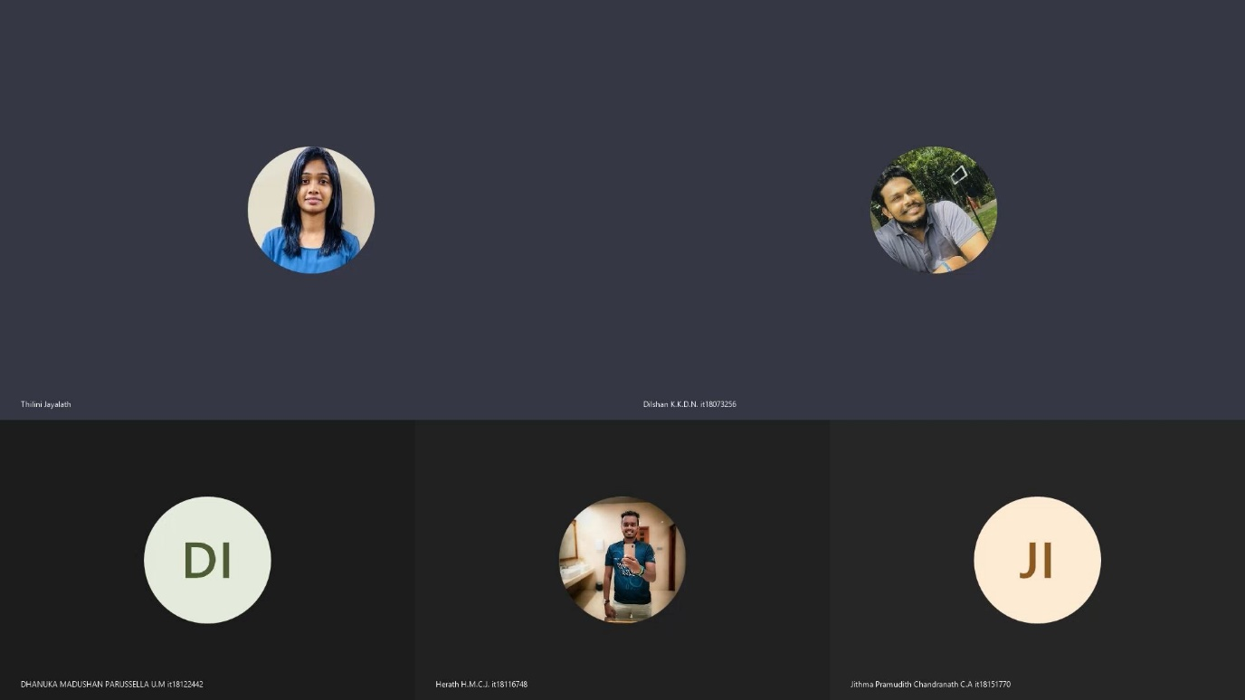

**Figure 1 – Meeting 18 Jan 2021**

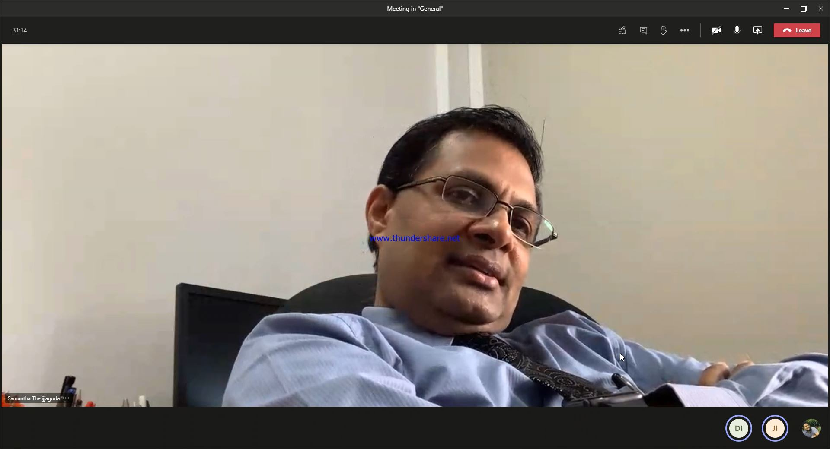

**Figure 2 – Meeting 15 Feb 2021**

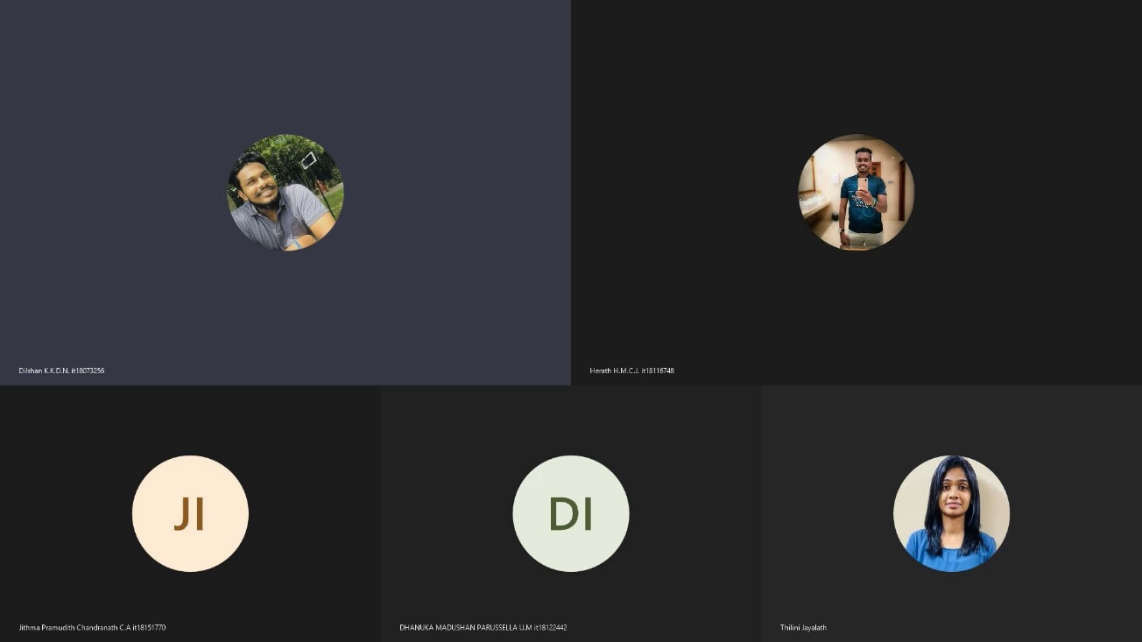

**Figure 3 – Meeting 20 Feb 2021**

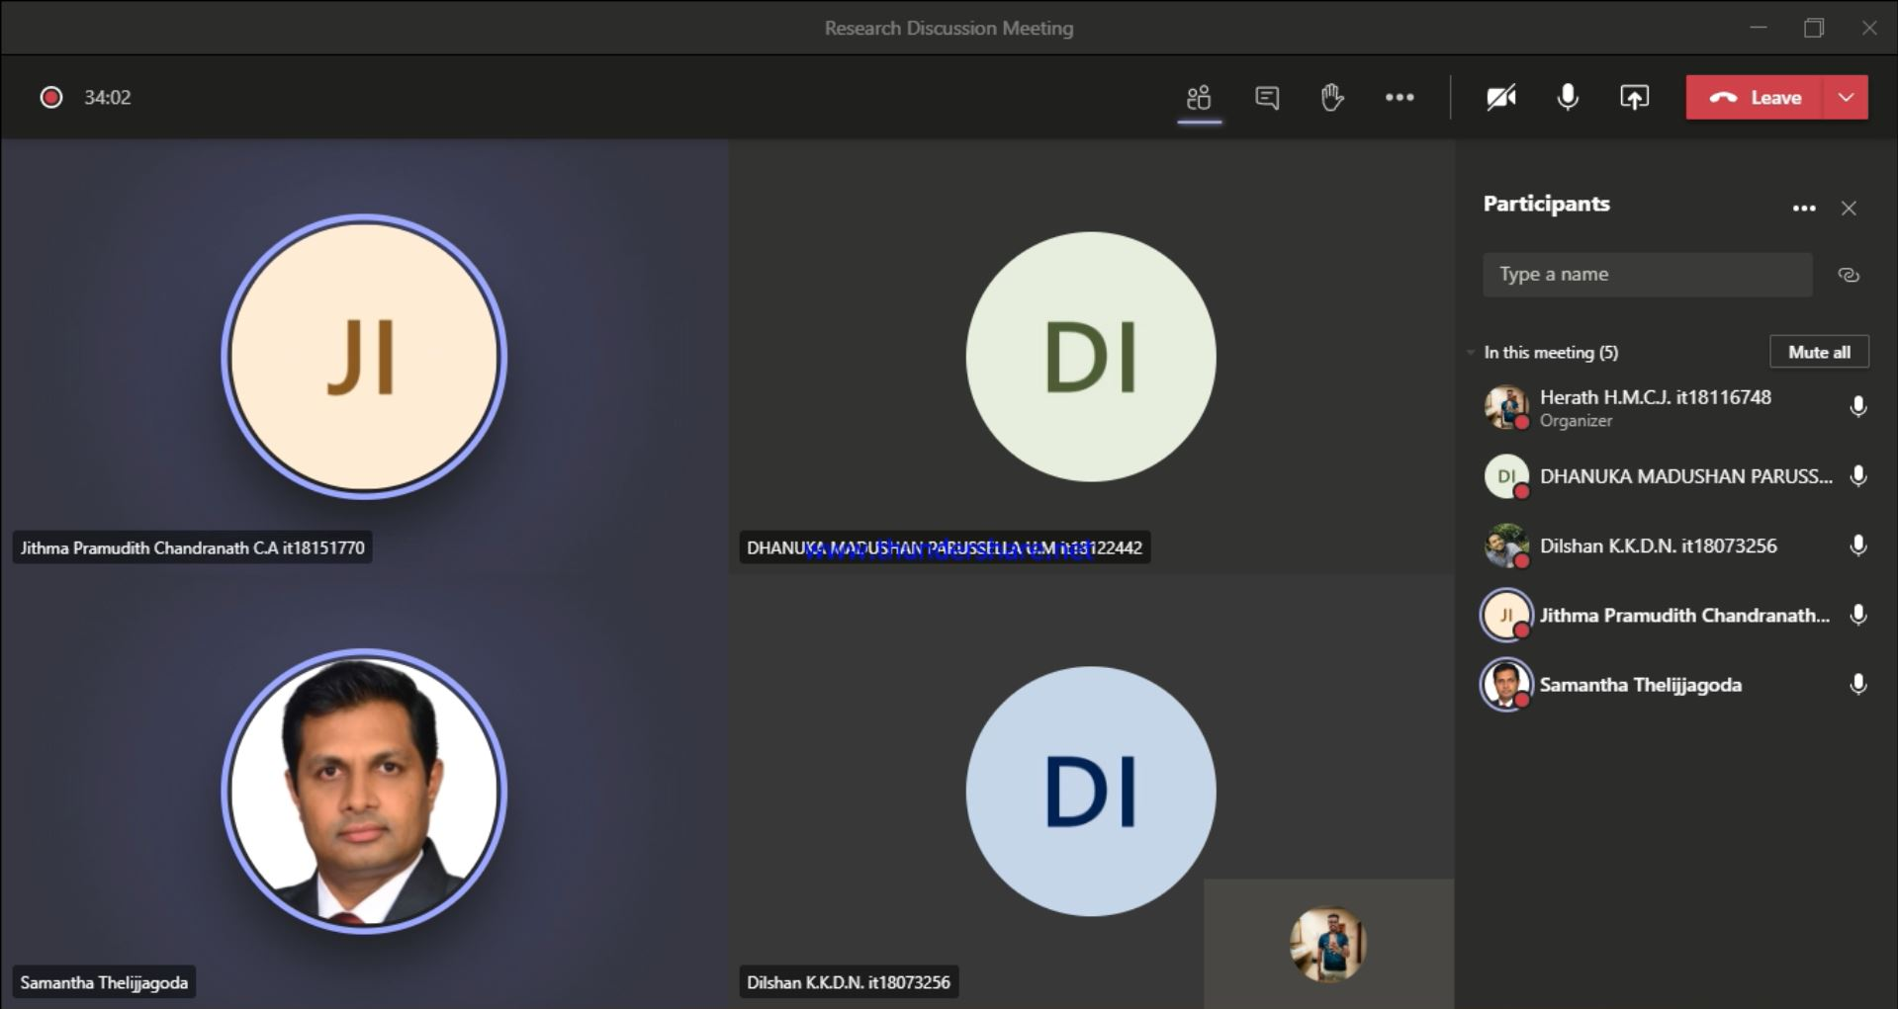

**Figure 4 – Meeting 11 Mar 2021**

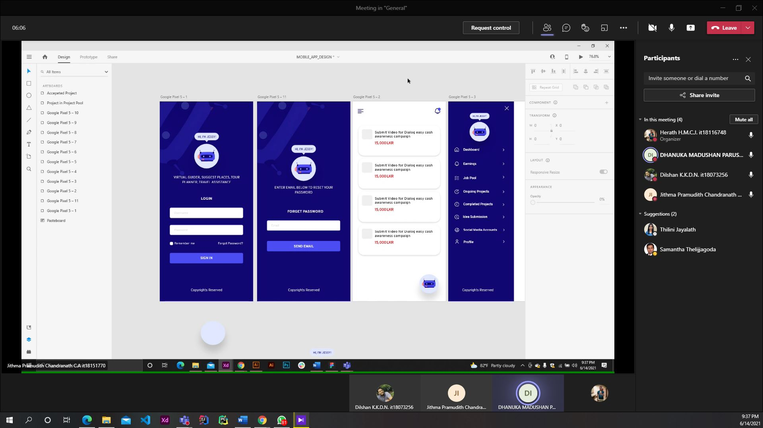

**Figure 5 – Frontend Discussion Meeting 17 Apr 2021**

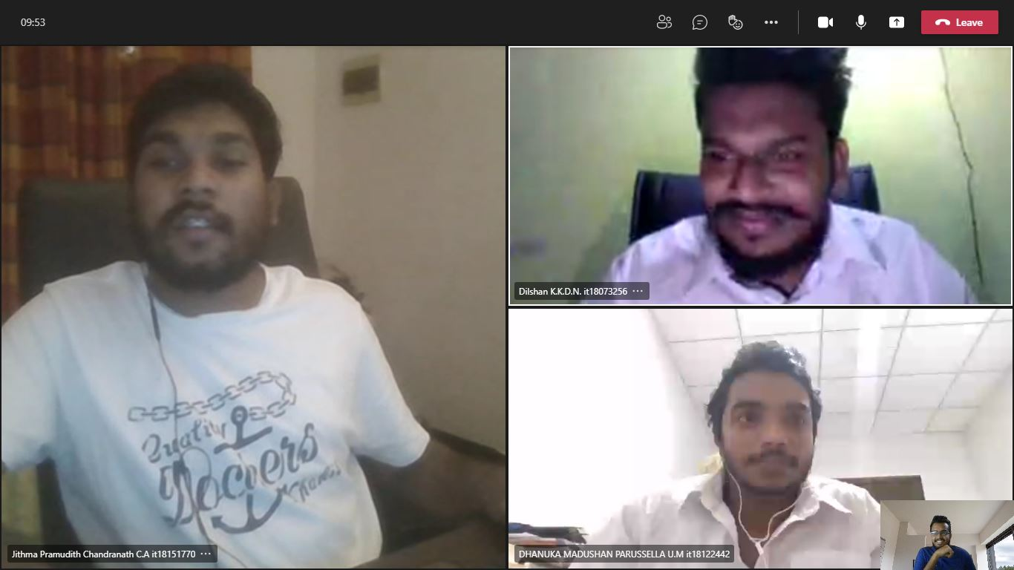

**Figure 6 – Meeting 27 May 2021**

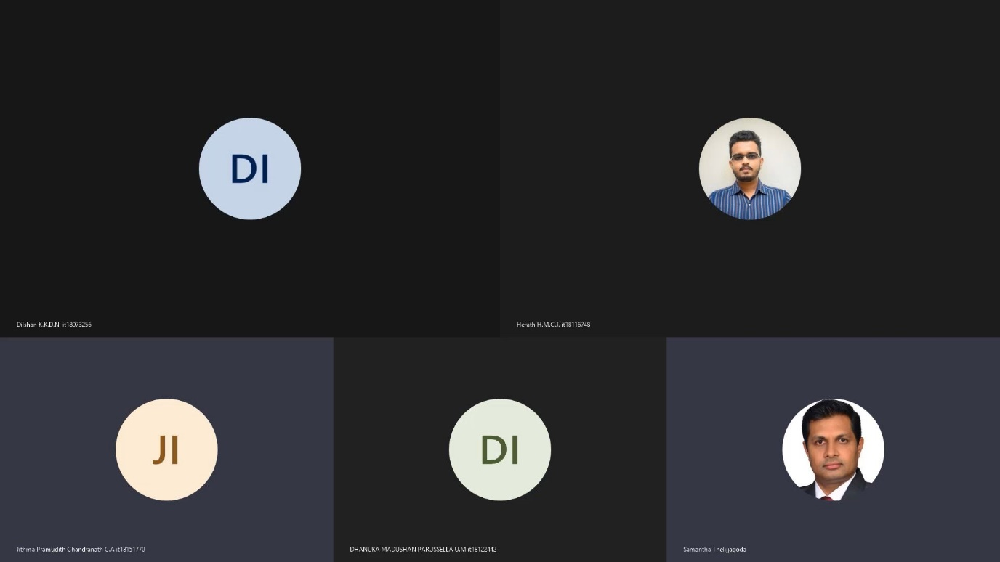

**Figure 7 – Meeting 30 June 2021**

# Microsoft Team Project Plan

**Figure 8 - Project Plan**

# Microsoft Planner Overall Analysis of Tasks

**Figure 9 -My Tasks Chart - 1**

**Figure 10 - My Tasks Chart - 2**

**Figure 11 - My Task Chart - 3**

# Work Breakdown Structure

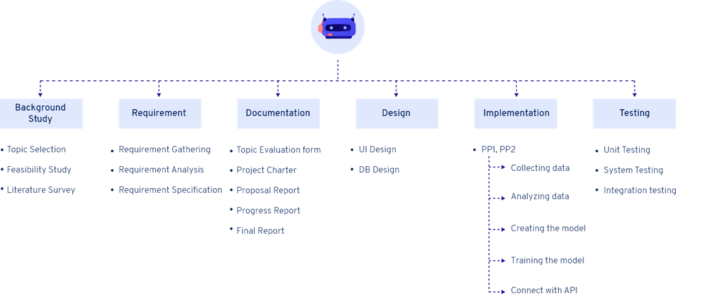

**Figure 12 - Work Breakdown Chart**



# Gantt Chart

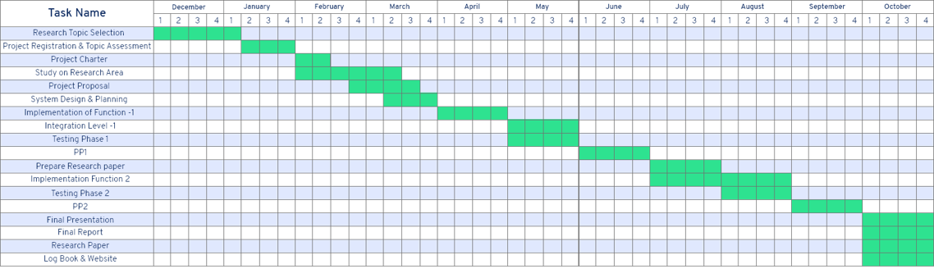

**Figure 13 - Gantt Chart**